Image Classification Assignment – Nike vs Addidas vs Reebok

Lucy (Sohyun Bae)

**1. The URL for your deployed web application**

<https://mybinder.org/v2/gh/sohyunbae1231/p_assignment/HEAD?urlpath=%2Fvoila%2Frender%2Fshoes_define.ipynb>

**2. A write up (PDF) that includes:**

* **the confusion matrix for your dataset (2 point)**

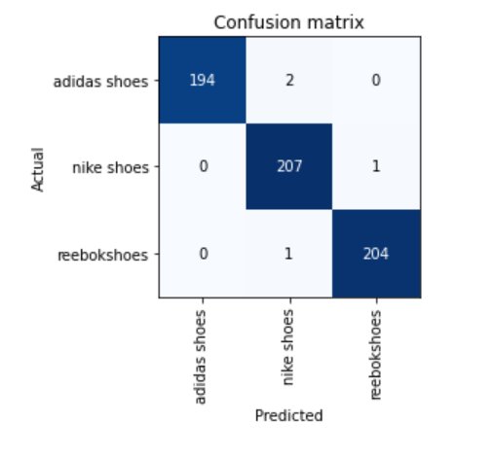

* **a screenshot of the output printed of the 10 images with the highest loss in your dataset (1 point)**
  + **Since data names are too long, I made them into a single line and captured them.**

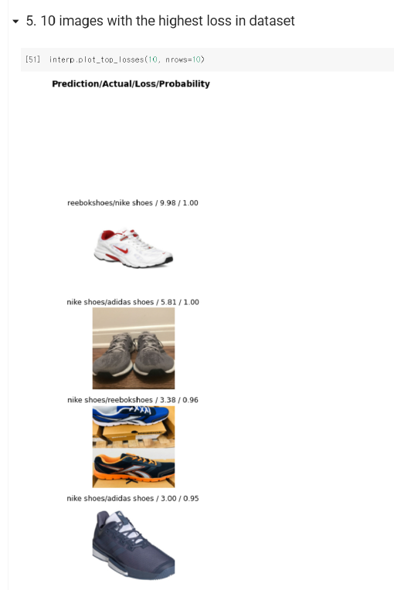

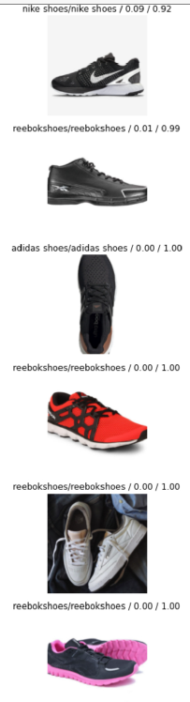

* **For each of the 10 images, give an explanation of why this image was included in the top loss plot, and the resulting action you took. Did you remove the image, why? And if not, why did you include it? (2 points)**



**=> 1. Ground Truth: Nike, Prediction: Reebok**

**This image is actually labeled as Nike shoes, but predicted as Reebok shoes – I think that this could be because the line in the marked area looks like Reebok logo.**

**So I decided to remove this image from the training set because it’s not correctly predicted.**

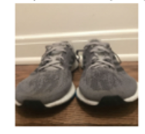

**=> 2. Ground Truth: Adidas, Prediction: Nike**

**This image is actually labeled as Adidas shoes, but predicted as Nike shoes – I think that this could be because there are no logos&patterns.**

**So I decided to remove this image from the training set because it’s a image that even people can't distinguish.**

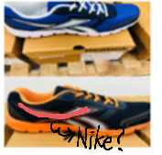

**=> 3. Ground Truth: Reebok, Prediction: Nike**

**This image is actually labeled as Reebok shoes, but predicted as Nike shoes – I think that this could be because the part marked in red can look like the Nike logo.**

**So I decided to remove this image from the training set because it’s not correctly predicted.**

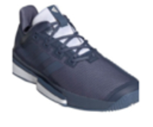

**=> 4. Ground Truth: Adidas, Prediction: Nike**

**This image is actually labeled as Adidas, but predicted as Nike shoes – I think that this could be because the three lines symbolizing Adidas are too faint.**

**So I decided to remove this image from the training set because it’s a image that even some people can't distinguish.**

**=> 5. Other images are labeled correctly.**

**So I don’t have to remove the image.**

**And here’s my results.**

**People can analyze their pictures by uploading pictures like this:**

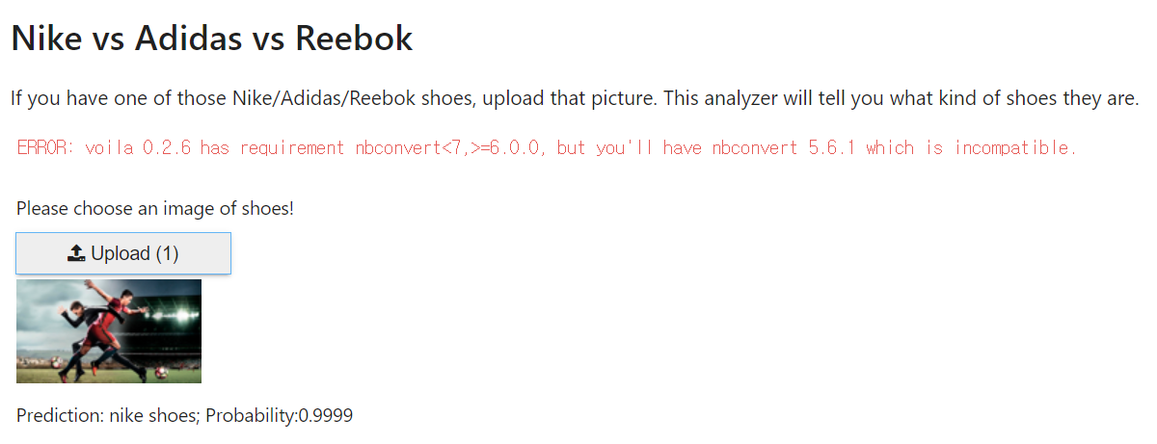

* **a summary of your approach to acquiring the data. (1 point)**

For acquiring more than 150 images, I used bing-image-downloader.

Downloading images was repeated until N images were obtained.

Therefore, N(N=1000) images were obtained, except for pages with errors.

